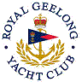 | Royal Geelong Yacht Club Inc.  Est 1859
Trophy Deed of Gift.

Trophy: | Walter M. Hitchcock Trophy
Presented by:
Date: | 1905
For: | Competitions: Corio Bay
Remarks / Revisions | 1974: I.O.R. Aggregate  Now. I.R.C. Aggregate
Click here to View IOR Recipients
Click here to View IRC Recipients

To read about the Hitchcock connection, click here.

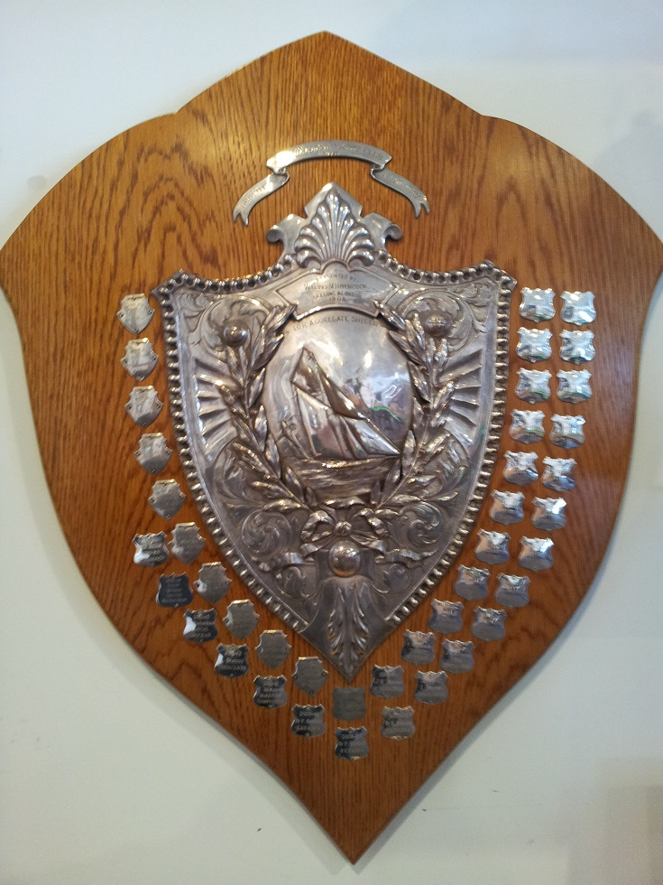

GEORGE MICHELMORE HITCHCOCK, (1831-1912)
WALTER MICHELMORE HITCHCOCK, (1832-1923),
businessmen, were sons of William Hitchcock, South Molton, Devon, England, and his first wife Mary Elizabeth, (nee Tope). George was born at Barnstaple on 7 October 1831 and Walter on 11 August 1832. After attending Denmark Hill School they were apprenticed to their uncle George, a London draper who also employed George Williams, founder of the Young Men's Christian Association.·
In 1849 the Hitchcock family migrated in the ‘Amity Hall’ to Geelong where in June 1850 they established Hitchcock Bros & Co., general dealers, wool-brokers and merchants. Walter and his father went to the Ballarat goldfields in September 1851 but were more successful at Forest Creek near Castlemaine. His father became a peoples' commissioner at Castlemaine in May 1853 to protest against police tyranny. Devout Congregationalists, father and son organized regular religion services, first in a marquee and later in the Castlemaine hall which William built as well as his own home. Known as the 'Duke of Muckleford' he was auctioneer, merchant, proprietor of livery stables and founder of the first local newspaper. In May 1854 he represented landowners and merchants before the directors of the Mount Alexander Railway Co. In November he was host to Mrs. Chisholm and offered to establish a home for girls in Castlemaine. He was vice-president of the local Friendly Aid Society, chairman of the hospital committee, promoter of schools and chairman of the municipality. He lost heavily in mining speculations and was declared insolvent in October 1859.
In May 1860 he moved to Brisbane and in 1861 to Sydney, where he had relations who had served in the London Missionary Society. Aged 55 he died in Melbourne on 29 April 1867, survived by his second wife and several children.
In 1852 Walter had returned to Geelong in September 1853 he and his brother George joined William Bright & Co., drapers and clothiers, and in January 1877 became sole partners. As buyer for the firm Walter had moved in 1863 to London where in 1865-66 his efforts to secure machinery and finance for a woollen mill in Geelong were strongly opposed in England but helped to create an independent colonial industry. In July 1881 he withdrew from the firm but under the management of George and later his son Howard (1866-1932), Bright & Hitchcocks became the largest department store in Victoria outside Melbourne.

